Kent County Middle School
Summer 2022 Reading List
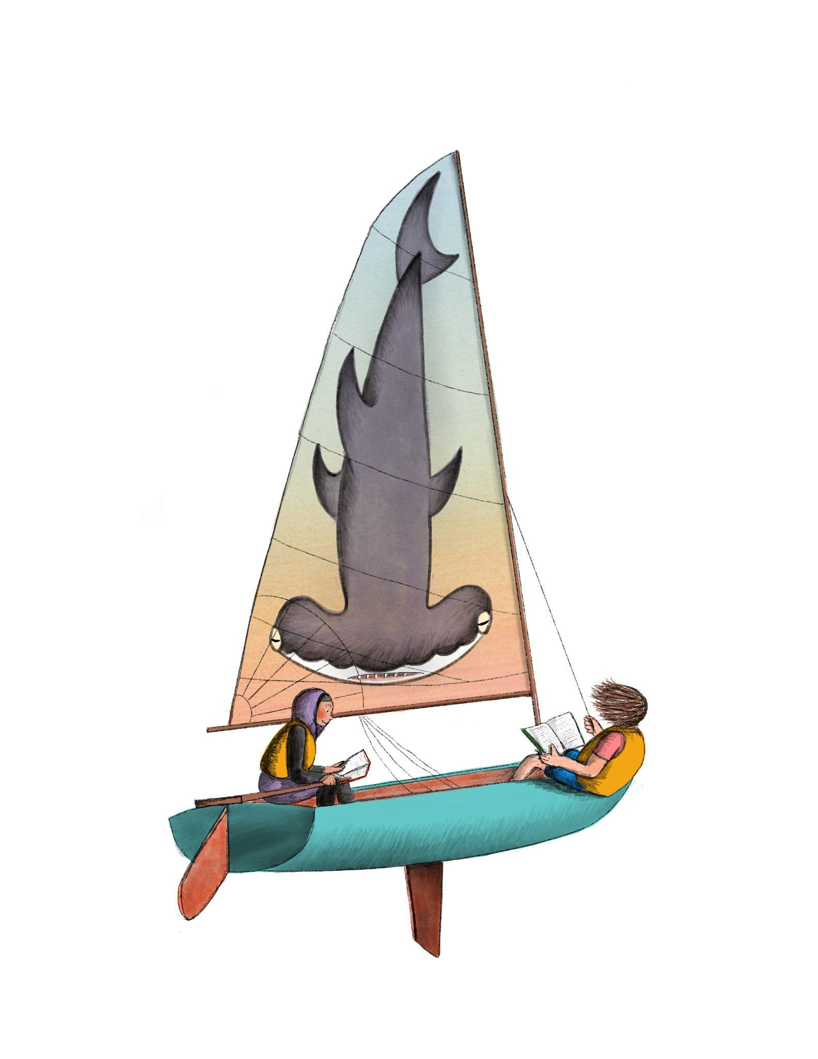
Students are required to choose at least one selection to read over the summer break and select an assignment from the choice board.

Entering 6th grade:
- The One and Only Ivan by Katherine Applegate
- Wonder by R.J. Palacio
- Peter and the Starcatcher by Dave Barry and Ridley Pearson
- The Alchemyst: The Secrets of the Immortal by Nicholas Flamel
- Keeper of the Lost Cities by Shannon Messenger
- Other Words for Home by Jasmine Warga
- Brown Girl Dreaming by Jacqueline Woods
- Found by Margaret Peterson Haddix
- Refugee by Alan Gratz
- Anne of Green Gables by L.M. Montgomery
Enjoy these classics too:
Heidi
Tom Sawyer
Little Women
Johnny Tremain
Across Five Aprils
No Promises in the Wind
Bud Not Buddy
The Indian in the Cupboard
The Orphan Train series

8 hours, 4 books, or 15 minutes a day 5 days a week, however you want to track it, just keep reading!

Help the Kent County Public Library reach the summer reading goal of 750,000 minutes read by the community.

Entering 7th grade:
- Crash by Jerry Spinelli
- Crispin: The Cross of Lead by Avi
- Fever 1793 by Laurie Halse-Anderson
- Heart to Heart by Lurlene McDaniel
- Rifle by Gary Paulsen
- Savvy by Ingrid Law
- Titanic, Voices from Disaster by Deborah Hopkinson
- Flush by Carl Hiaasen
- Maze Runner (any in the series by James Dashner

Entering 8th grade:
- Ready Player One by Ernest Cline
- Monster by Walter Dean Myers
- Enders Game by Orson Scott Card
- The Fault in Our Stars by John Green
- The Book Thief by Markus Zusak
- Divergent (any in the trilogy) by Veronica Roth
- Handbook for Boys: A Novel by Walter Dean Myers
- The Wednesday Wars by Gary D. Schmidt

Independent Reading SUMMATIVE Projects

Choose a square from one of the 9 squares to show what you know about your book.

You will be required to complete a project for the book you read.

**Remember: All work is expected to be original. Work that is plagiarized will not be accepted.**

Brochure  Create a 5 panel brochure. Include the following:  Author, Title, Reflection  Book Review/ Star Rating, About the Book, About the Author  Remember to integrate cited text evidence! | Movie Poster  Create a movie poster. Include a vibrant drawing, title, author, list of actors and the characters they are playing, etc. Remember to integrate cited text evidence to enhance the visuals and text on the poster. | Music  Write a rap, song, or poem about the main character or book/story. You must have at least four stanzas. Don’t forget to integrate cited text evidence! As an option, you can create a video or audio recording of a performance of your project.
StoryBoard  Draw at least six important scenes from the book in chronological order with captions. Remember to include cited text evidence! | Book Jacket  Create a book jacket  Include at least a drawing, the title, author, 5 sentence summary to hook the next reader, and a review of the book. Remember to integrate cited text evidence! | Timeline  Create a timeline of your story with 12 events that you consider to be the most important events in the plot. Remember to integrate cited text evidence!
Google Slideshow  Create a Google slideshow.  Include at least: Author, Title, Reflection, Book Review/ Star Rating, book summary, a brief biography of the Author  Remember to integrate cited text evidence! | Quiz  Create a 15 question quiz for the book/story. Remember to include the answer key. No more than 5 questions should be multiple choice. All questions should demonstrate a deep understanding of the text. Remember to integrate cited text evidence! | Video/Vlog  Create a video or script in which you reflect on the book you read. Your video must at least include a reflection, review, of the book, and a brief biography of the author. Remember to integrate cited text evidence!

**Remember: All work is expected to be original. Work that is plagiarized will not be accepted.**

Rubric

Criteria | Grading Scale
Demonstration of Knowledge  Demonstration of knowledge of the text as a whole throughout the project | 3 Good The student illustrates intimate knowledge of the text (plot, characters, and details that the student would only know if read). 2 Satisfactory The student shows knowledge of the text but lacks details about the plot or characters that could be important. 1 Needs Improvement The student demonstrates a basic or surface-level understanding of the plot and characters; Reading may not have been completed.
Use of Textual Evidence | 3 Good The student uses at least 3 pieces of textual evidence to support their demonstration of knowledge of the text as well as references page numbers. 2 Satisfactory The student uses at least 1 or 2 pieces of textual evidence or may paraphrase pieces of the book to support their demonstration of knowledge. Page numbers may or may not be present. 1 Needs Improvement The student does not use any textual evidence or does not refer to specific places in their book.
Completion of Project Requirements | 3 Good Students completed one of the 9 options; All of the requirements of that project are present. 2 Satisfactory Students completed one of the 9 options; Some requirements of that project are present. 1 Needs Improvement The student did not complete one of the 9 options or did not follow the requirements of the project chosen.
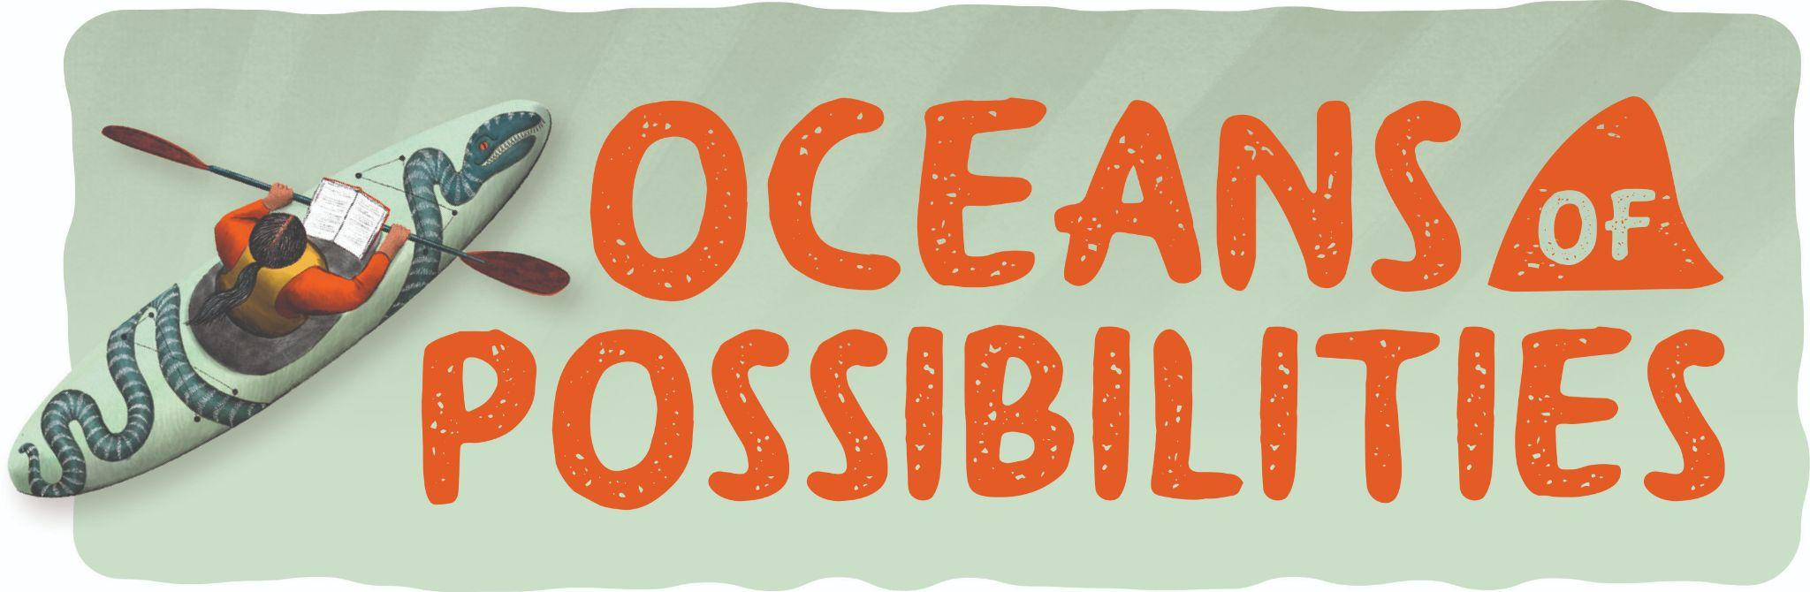

+1 Point for Timely Submission!
